Logical Database Design
Logical database design is about arranging data in a structured way to ensure it can be efficiently stored, retrieved, and maintained. It involves defining tables, columns, and the relationships between them based on the requirements gathered during the earlier stages of database design.
2. Relational Model
The relational model organizes data into tables (also called relations). Each table has rows (also called tuples) and columns (also called attributes).
3. Relations
A relation is essentially a table with rows and columns. Each row represents a unique record, and each column represents a field in the record.
Example:
- Table Name: Students
- Columns: StudentID, Name, Age, Major
- Rows: Each student's details.
4. Relation Keys
Keys are special fields that uniquely identify rows in a table.
- Primary Key: A field (or combination of fields) that uniquely identifies each row in a table.
Example:
- In the Students table, StudentID can be the primary key because each student has a unique ID.
- Foreign Key: A field in one table that links to the primary key in another table, creating a relationship between the two tables.
Example:
- If there is another table called Enrollments with columns EnrollmentID, StudentID, CourseID, the StudentID in the Enrollments table would be a foreign key linking to the StudentID in the Students table.
5. Integrity Constraints
Integrity constraints ensure the accuracy and consistency of data in the database.
- Domain Constraint: Specifies the permissible values for a given column.
Example:
- The Age column in the Students table can have a domain constraint that only allows integers between 18 and 100.
- Entity Integrity: Ensures that the primary key value for every row is unique and not null.
Example:
- Each student must have a unique StudentID, and it cannot be empty.
- Referential Integrity: Ensures that a foreign key value always points to an existing record in another table.
Example:
- If StudentID in the Enrollments table refers to StudentID in the Students table, referential integrity ensures that you can't add a record in Enrollments with a StudentID that doesn't exist in the Students table.
6. Transforming ERD and EERD into Relations
- ERD (Entity-Relationship Diagram): A visual representation of the entities (tables) and their relationship

What is an ER diagram?
An entity-relationship (ER) diagram, also called an entity-relationship model, is aptly named: it shows the relationships between entities. ER diagrams are most commonly used to organize data within databases or information systems.
There are two kinds of ER diagrams: conceptual and physical. Conceptual diagram models can provide the foundation for logical data models or show commonality relationships between ER models as a basis for data-model integration.

Learn the entity-relationship diagram symbol series
A conceptual ER diagram uses six standard symbols.
- Entities are objects or concepts that represent important data. Also known as strong entities or parent entities, these entities will often have weak entities that depend on them.
- Attributes are characteristics of an entity (i.e., many-to-many or one-to-one).
- Relationships are associations between entities.
- Weak entities depend on another entity.
- Multivalued attributes are attributes that can have more than one value.
- Weak relationships are the connections between a weak entity and its parent. 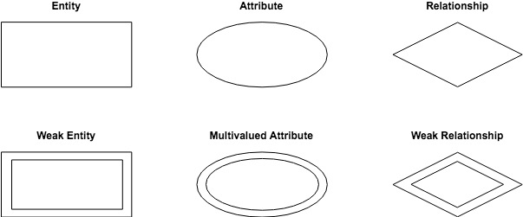

Physical diagram models are more granular, showing the processes necessary for adding information to a database. Rather than using symbols, they consist of a series of tables.
Each entity is represented as a table, with each field acting as an attribute of the entity containing it.

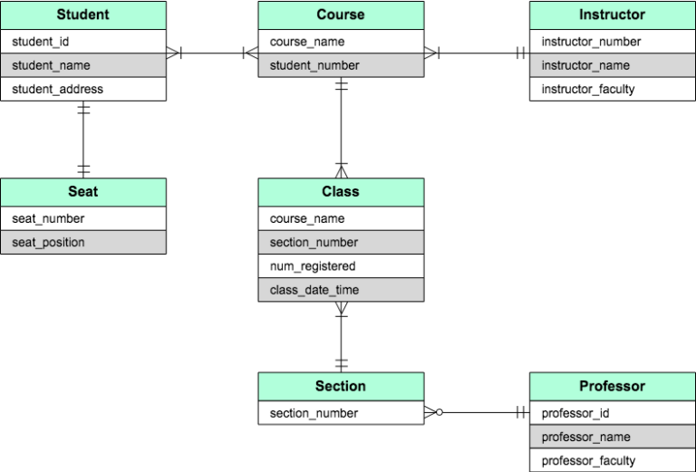
Entities are connected via a system of notation called crow’s foot notation. The styling of the endpoint of each line distinguishes the relationship. 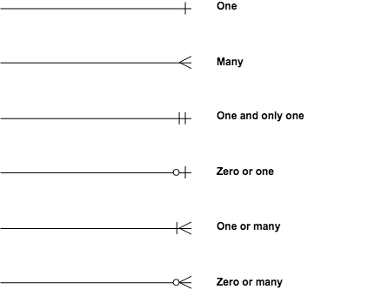

Relationships can be one-to-one (1:1) or one-to-many (1:m). In some instances, the relationship will include many to many (m:m).

Enhanced Entity-Relationship Modeling (EER) Explained with Everyday Examples
Imagine you're organizing a giant family reunion! An EER diagram helps you visualize all the family members (entities) and their relationships in a clear way. But unlike a regular family tree, EER lets you show more complex connections, like uncles who are also doctors!
Here's a breakdown of the key concepts with relatable examples:
1. Entities and Attributes:
- Entities: These are the main things you're representing, like People in the family reunion.
- Attributes: These are the characteristics of entities, like Name, Age, Profession for People.
2. Supertype & Subtype (Specialization & Generalization):
- Think of a big family photo with grandparents at the top.
  - Supertype: This is the broader category, like Family Member in the photo.
  - Subtype: These are more specific groups within the supertype, like Grandparents, Parents, Children (specializations of Family Member).
  - Generalization: It's the process of moving from specific subtypes to a more general supertype (like going from Grandparents to Family Member).
Example:
- Supertype: Vehicle (entity)
  - Subtypes: Car, Truck, Motorcycle (specializations)
3. Specifying Constraints:
These are rules that ensure your EER diagram makes sense in the real world. Here are a few examples:
- Completeness Constraint: Every Family Member must belong to a subtype (Grandparent, Parent, Child). No one is just a floating "Family Member" without a specific role.
- Disjoint Constraint: A person cannot be a Child and a Grandparent at the same time (they are mutually exclusive).
4. Benefits of EER Diagrams:
- Clearer visualization of complex relationships.
- Easier to identify potential data inconsistencies.
- Helps in designing efficient databases.
Daily Life Example:
Imagine a library database. Here's how EER can help:
- Entity: Book, Author, Librarian, Patron
- Supertype: Library Item (Book, Audiobook, Movie)
- Subtype: Book (Fiction, Non-Fiction) - Fiction and Non-Fiction are specializations of Books.
- Constraint: A Patron cannot borrow more books than allowed (completeness constraint).

- EERD (Enhanced Entity-Relationship Diagram): An extension of ERD that includes additional concepts like subtypes and supertypes (inheritance).

Here we just need to add a few things to above.
1. As in drawing ER diagrams first, we have to identify all entities.
After we found entities from the scenario you should check whether those entities have sub-entities. If so you have to mark sub-entities in your diagram.
Dividing entities into sub-entities we called as specialization. And combining sub-entities to one entity is called a generalization.
Then you have to identify relationships between entities and mark them.
3. Add attributes for entities. Give meaningful attribute names so they can be understood easily.
4.Mark the cardinalities and participation
If it is an EER diagram you have to add a few to your diagram.
Here also we have to check whether sub-entities totally depend on the main entity or not. And you should mark it.
If all members in the superclass(main entity) participate in either one subclass it is known as total participation. It marks by double lines.
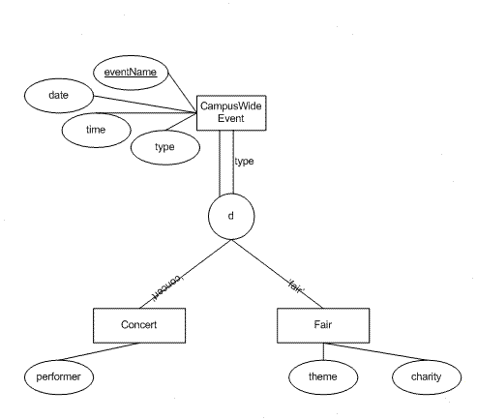
If at least one member in the superclass does not participate in subclass it is known as partial participation. It is denoted by one single line.

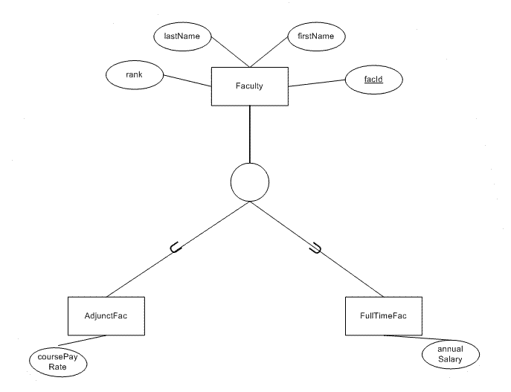

If all the members in the superclass participate for only one subclass it is known as disjoint and denoted by “d”. If all the members in the superclass participate in more than one subclass it is known as overlap and denoted by “o”.
Steps to transform ERD/EERD into relations:
- Identify Entities and Attributes: Each entity becomes a table, and each attribute becomes a column in that table.
  - Example: In an ERD with an entity "Student," we create a Students table with columns for each attribute like StudentID, Name, Age, Major.
- Determine Primary Keys: Choose a unique identifier for each table.
  - Example: StudentID for the Students table.
- Establish Relationships: Create foreign keys to represent relationships between tables.
  - Example: If there's a relationship between Students and Courses via Enrollments, the Enrollments table will have StudentID and CourseID as foreign keys.
- Normalize Data: Ensure data is stored efficiently, reducing redundancy.
  - Example: Instead of storing student names in both Students and Enrollments tables, store them only in Students and reference StudentID in Enrollments.
Daily Life Example: Imagine a library system:
- Entities: Books, Members, Loans.
- Attributes:
  - Books: BookID (Primary Key), Title, Author, ISBN.
  - Members: MemberID (Primary Key), Name, Address.
  - Loans: LoanID (Primary Key), BookID (Foreign Key), MemberID (Foreign Key), LoanDate.
- Relationships:
  - A member can borrow multiple books (One-to-Many).
  - Each loan involves one book and one member.
This library system example illustrates how entities, keys, constraints, and relationships work together to create a structured and efficient database.
Here is an EER (Enhanced Entity-Relationship) diagram for the library system:
Entities:
- Books
- BookID (Primary Key)
- Title
- Author
- ISBN
- Members
- MemberID (Primary Key)
- Name
- Address

- Loans
- LoanID (Primary Key)
- BookID (Foreign Key) referencing Books
- MemberID (Foreign Key) referencing Members
- LoanDate
Relationships:
- A book can have many loans (one-to-many): Books(BookID) → Loans(BookID)
- A member can have many loans (one-to-many): Members(MemberID) → Loans(MemberID)
- A loan is associated with one book and one member (many-to-one): Loans(BookID) → Books(BookID), Loans(MemberID) → Members(MemberID)

Difference between Strong and Weak Entity
An entity is a “thing” or “object” in the real world. An entity contains attributes, which describe that entity. So anything about which we store information is called an entity. Entities are recorded in the database and must be distinguishable, i.e., easily recognized from the group. In this article we will see difference between strong and weak entity.
What is Strong Entity?
A strong entity is not dependent on any other entity in the schema. A strong entity will always have a primary key. Strong entities are represented by a single rectangle. The relationship of two strong entities is represented by a single diamond. Various strong entities, when combined together, create a strong entity set.
What is Weak Entity?
A weak entity is dependent on a strong entity to ensure its existence. Unlike a strong entity, a weak entity does not have any primary key. It instead has a partial discriminator key. A weak entity is represented by a double rectangle. The relation between one strong and one weak entity is represented by a double diamond. This relationship is also known as identifying relationship.
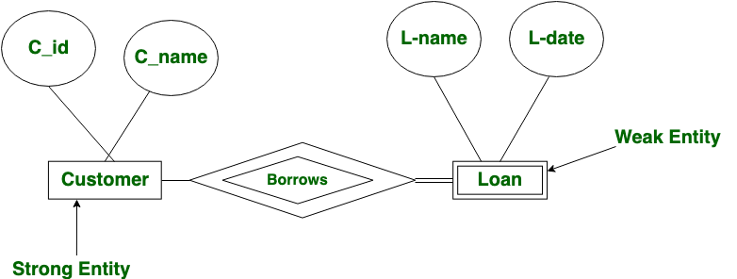

Difference between Strong and Weak Entity
Strong Entity | Weak Entity
Strong entity always has a primary key. | While a weak entity has a partial discriminator key.
Strong entity is not dependent on any other entity. | Weak entity depends on strong entity.
Strong entity is represented by a single rectangle. | Weak entity is represented by a double rectangle.
Two strong entity’s relationship is represented by a single diamond. | While the relation between one strong and one weak entity is represented by a double diamond.
Strong entities have either total participation or not. | weak entity always has total participation.

Imagine a university database that tracks student enrollments in courses.
- Strong Entity: Course (with attributes like CourseID (PK), CourseName, Department)
- Weak Entity: Enrollment (with attributes like EnrollmentID, Semester, Grade)
Explanation:
- Course: This is the strong entity with a primary key CourseID. It represents the various courses offered by the university.
- Enrollment: This is the weak entity that depends on the Course entity. It stores information about student enrollments in specific courses.
Partial Discriminator Key:
- EnrollmentID alone cannot uniquely identify an enrollment record. Multiple students might be enrolled in the same course during a particular semester.
- In this case, the partial discriminator key would be a combination of:
  - CourseID (from the Course table)
  - Semester (from the Enrollment table)
Why it's Partial?
- Neither CourseID nor Semester can uniquely identify an enrollment record on their own.
  - Multiple students can be enrolled in the same course (CourseID) during a semester.
  - A student can enroll in multiple courses (Semester) during the same semester.
- However, together, CourseID and Semester act as a partial identifier for enrollments within the Enrollment entity.
Introduction to data mining (data ware housing, OLAP, OLTP)
Imagine you're a detective looking for clues in a mountain of information. Data mining is similar, but instead of fingerprints at a crime scene, you're looking for patterns and insights hidden in a vast amount of data.
Here's a breakdown of the key players involved in data mining:
- Data Warehouse: This is like a giant storage room where you gather information from all sorts of sources, like store transactions, website clicks, or social media posts. It's a central location for all your data, organized and ready for analysis.
- OLTP (Online Transaction Processing): Think of this as the constant flow of new information coming into your data warehouse. Every time someone buys something online, clicks on a website, or uses an app, that's OLTP in action. It captures the day-to-day activities that generate data.
- OLAP (Online Analytical Processing): This is where you put on your detective hat and start analyzing the data in the warehouse. OLAP tools allow you to slice and dice the information in different ways, like looking at sales by region, product category, or time period. It helps you find hidden patterns and trends.
Daily Life Example:
Imagine you run a clothing store. Traditionally, you might just look at your daily sales figures. But with data mining, you can delve deeper. You can use OLAP to analyze:
- What clothes sell best together? (Data mining can help you identify patterns, like people who buy jeans often buy belts too.)
- What are the buying trends by season or location? (Do people in colder climates buy more sweaters?)
- Who are your most loyal customers? (Data mining can help you target promotions to specific customer groups.)
By using data mining techniques, you can gain valuable insights from your data, just like a detective finding clues. This can help you make better business decisions, improve marketing strategies, and ultimately, increase your sales!

